Lab 8
Task 1
CREATE VIEW view_flights_by_date AS
SELECT *
FROM flights
WHERE scheduled_departure = CURRENT_DATE;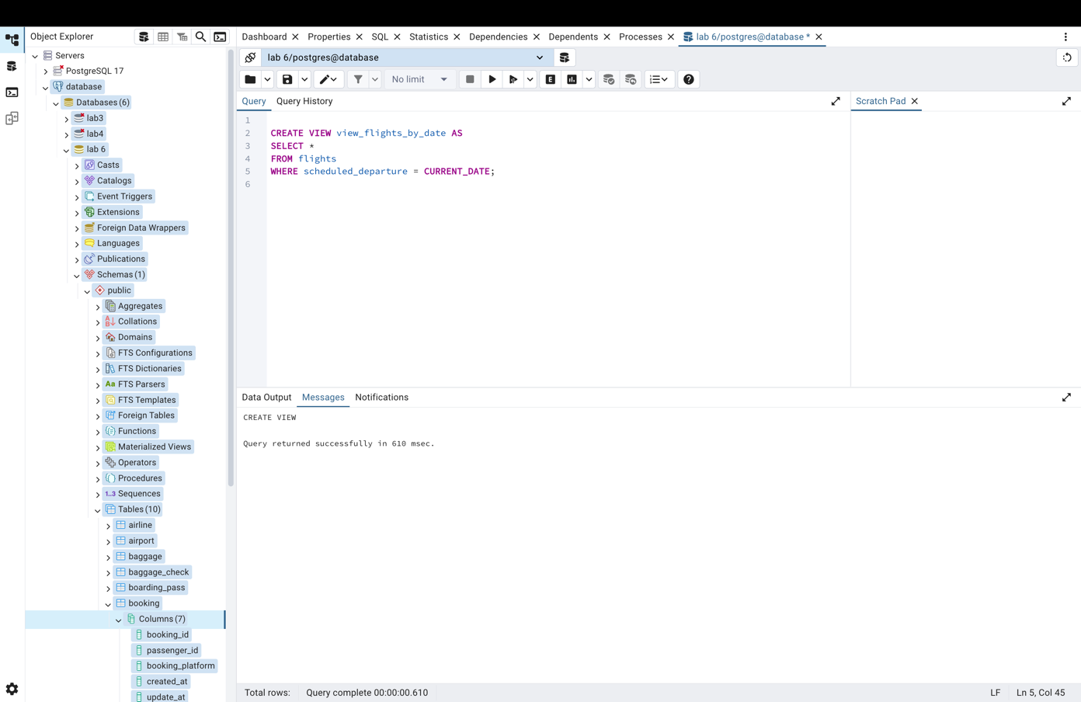
Task 2
CREATE VIEW view_bookings_next_week AS
SELECT b.booking_id, b.passenger_id, bf.flight_id, f.scheduled_departure
FROM booking b
JOIN booking_flight bf ON b.booking_id = bf.booking_id
JOIN flights f ON f.flight_id = bf.flight_id
WHERE f.scheduled_departure BETWEEN CURRENT_DATE AND CURRENT_DATE + INTERVAL '7 days';
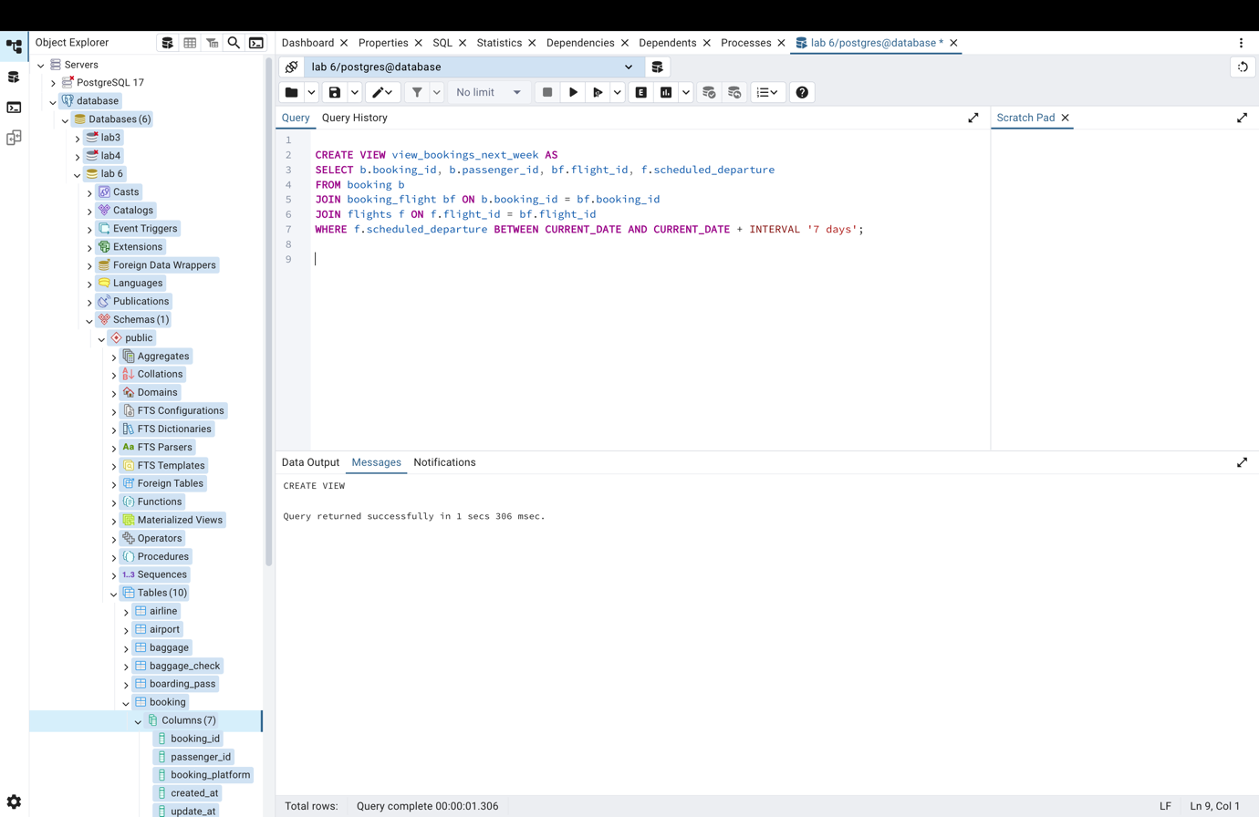
Task 3
CREATE VIEW view_top5_routes AS
SELECT
f.departure_airport_id,
f.arrival_airport_id,
COUNT(bf.booking_id) AS total_bookings
FROM flights f
JOIN booking_flight bf ON f.flight_id = bf.flight_id
GROUP BY f.departure_airport_id, f.arrival_airport_id
ORDER BY total_bookings DESC
LIMIT 5;

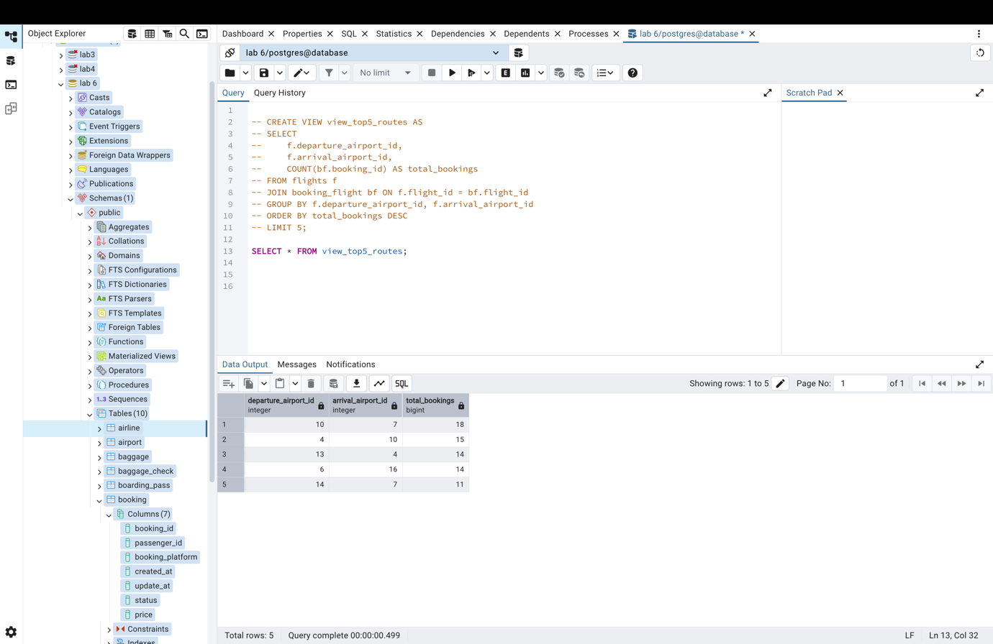
Task 4
CREATE VIEW view_flights_by_airline AS
SELECT *
FROM flights
WHERE airline_id = 1;
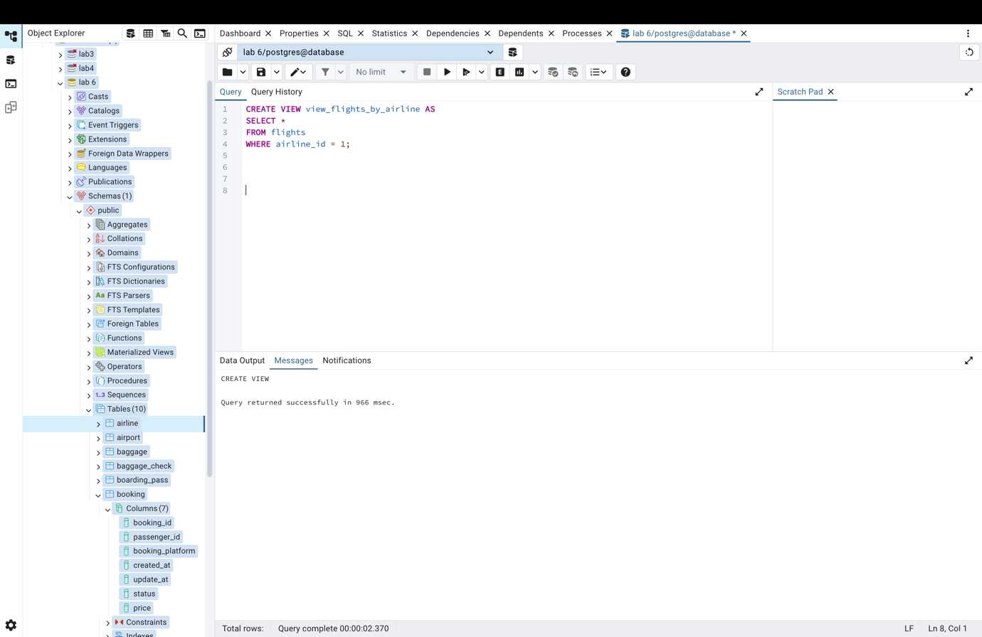
Task 5
DROP VIEW view_flights_by_airline;

CREATE VIEW view_flights_by_airline AS
SELECT *
FROM flights
WHERE airline_id = 1
AND scheduled_departure BETWEEN CURRENT_DATE AND CURRENT_DATE + INTERVAL '7 days';
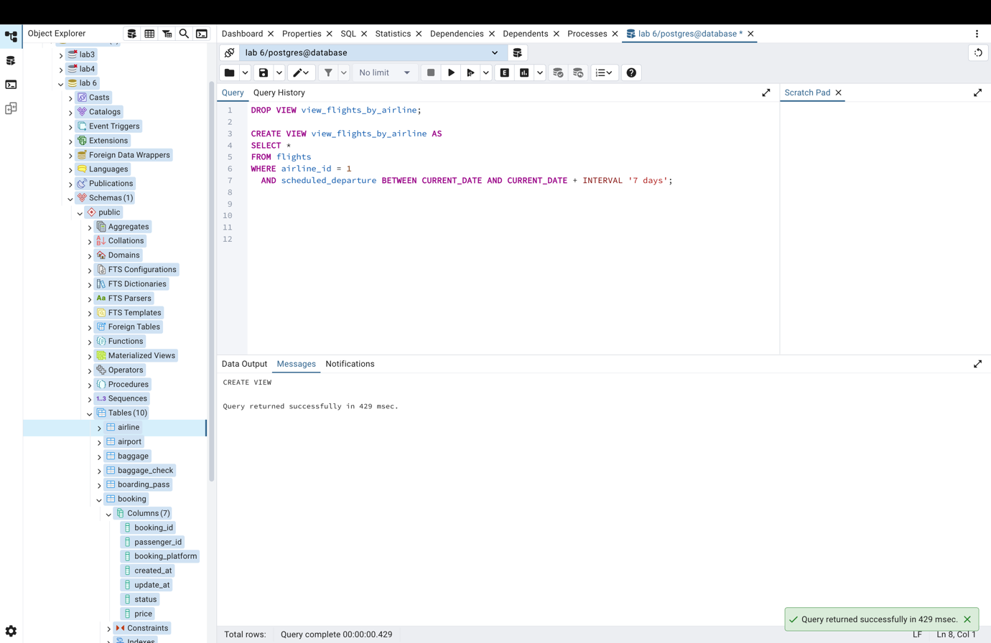
Task 6
CREATE VIEW view_delayed_24h AS
SELECT *,
actual_departure - scheduled_departure AS delay_time
FROM flights
WHERE actual_departure IS NOT NULL
AND actual_departure > scheduled_departure + INTERVAL '24 hours';
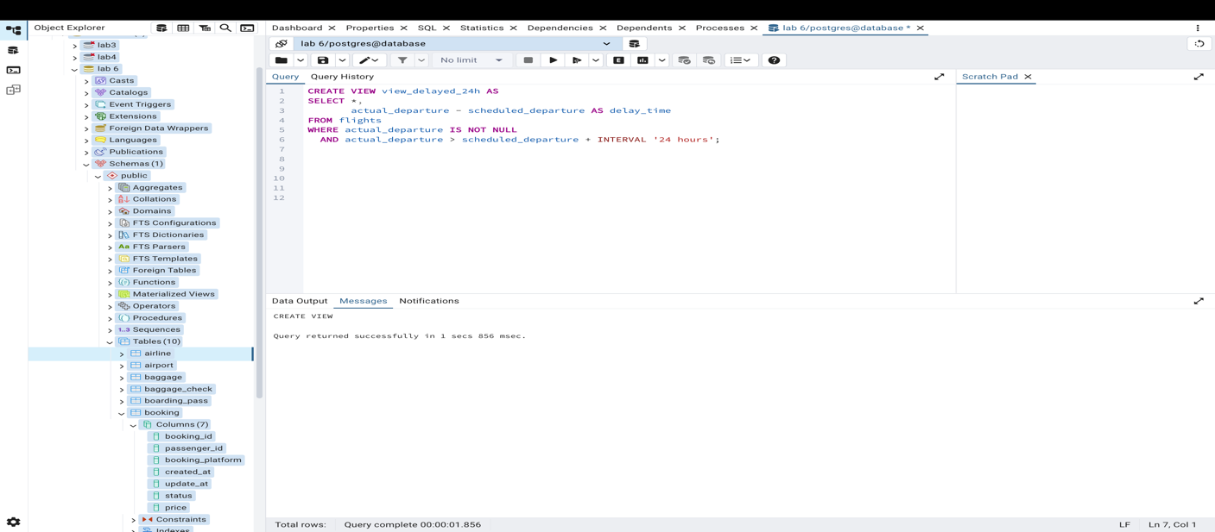

Task 7
CREATE VIEW view_LT_passengers AS
SELECT
p.passenger_id,
CONCAT(p.first_name, ' ', p.last_name) AS full_name,
p.country_of_citizenship,
b.booking_id,
b.booking_platform
FROM passengers p
JOIN booking b ON p.passenger_id = b.passenger_id
WHERE b.booking_platform = 'Leffler-Thompson';
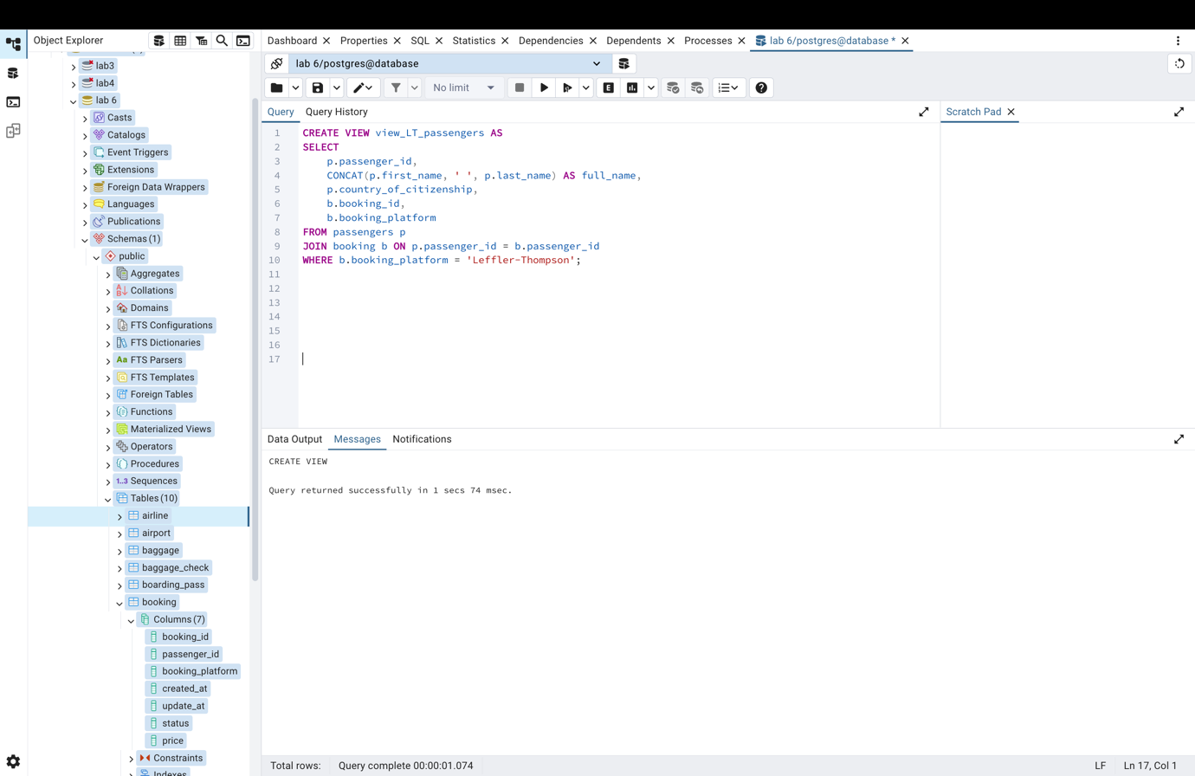
Task 8
CREATE VIEW view_top10_countries AS
SELECT
a.country,
COUNT(f.flight_id) AS visits
FROM flights f
JOIN airport a ON f.arrival_airport_id = a.airport_id
GROUP BY a.country
ORDER BY visits DESC
LIMIT 10;
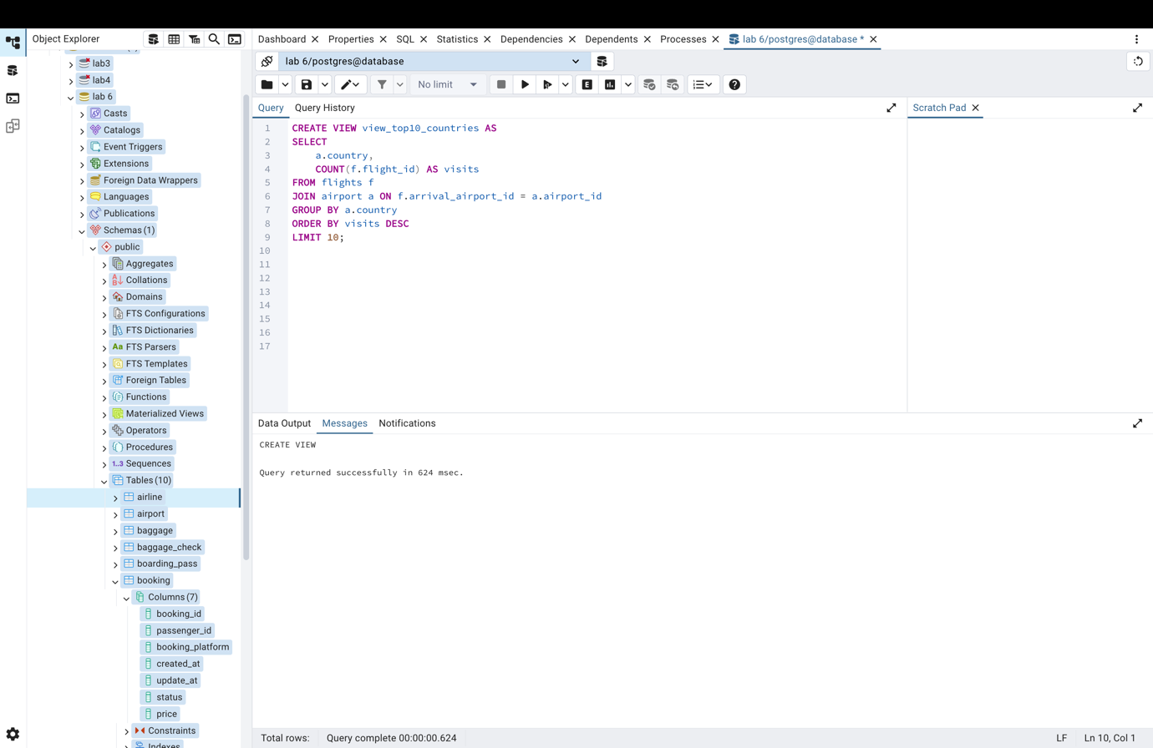
Task 9
CREATE OR REPLACE VIEW view_flights_by_date AS
SELECT f.*, al.airline_name
FROM flights f
JOIN airline al ON f.airline_id = al.airline_id
WHERE f.scheduled_departure = CURRENT_DATE;
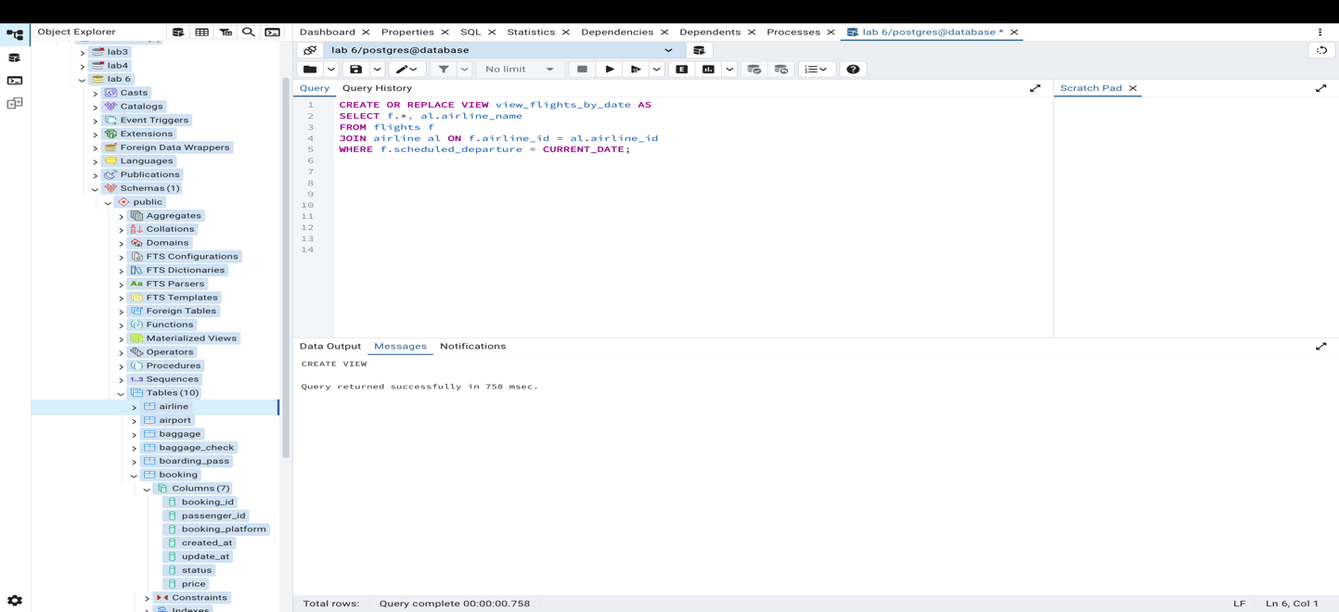
Task 10
DROP VIEW IF EXISTS
view_flights_by_date,
view_bookings_next_week,
view_top5_routes,
view_flights_by_airline,
view_delayed_24h,
view_LT_passengers,
view_top10_countries
CASCADE;
